**OCTAL TO BINARY CONVERSION:**

**EXP NO:31**

**AIM:**To write a C program to implement octal-to-binary conversion.

**APPARATUS:** DEV C++

**ALGORITHM:**

1)Input the octal number.

2)Count the total number of digits in the given number.

3)Assume that the number has n digits.

4)Multiply each digit in the number with 8^(n-1), when the digit is in the nth position.

5)Perform the addition of all the digits after multiplication.

6)The added sum gives the decimal equivalent of the octal number.

**PROGRAM:**#include<stdio.h>  
#include<math.h>  
int OctalToDecimal(int n) {  
int p = 0, decimal = 0, r;  
while(n>0){  
        // retrieving the right-most digit of n  
        r = n % 10;  
        // dividing n by 10 to remove the  
        // right-most digits since it is already  
        // scanned in the previous step  
        n = n / 10;  
        decimal = decimal + r * pow( 8 , p);     
        ++p;  
}     
return decimal;  
}  
int main() {    
int n, i, k;  
printf("Enter Octal: ");  
scanf("%d", &n);  
printf("\nDecimal of Octal Number %d is : %d", n,OctalToDecimal(n));     
return 0;  
}

**INPUT:**

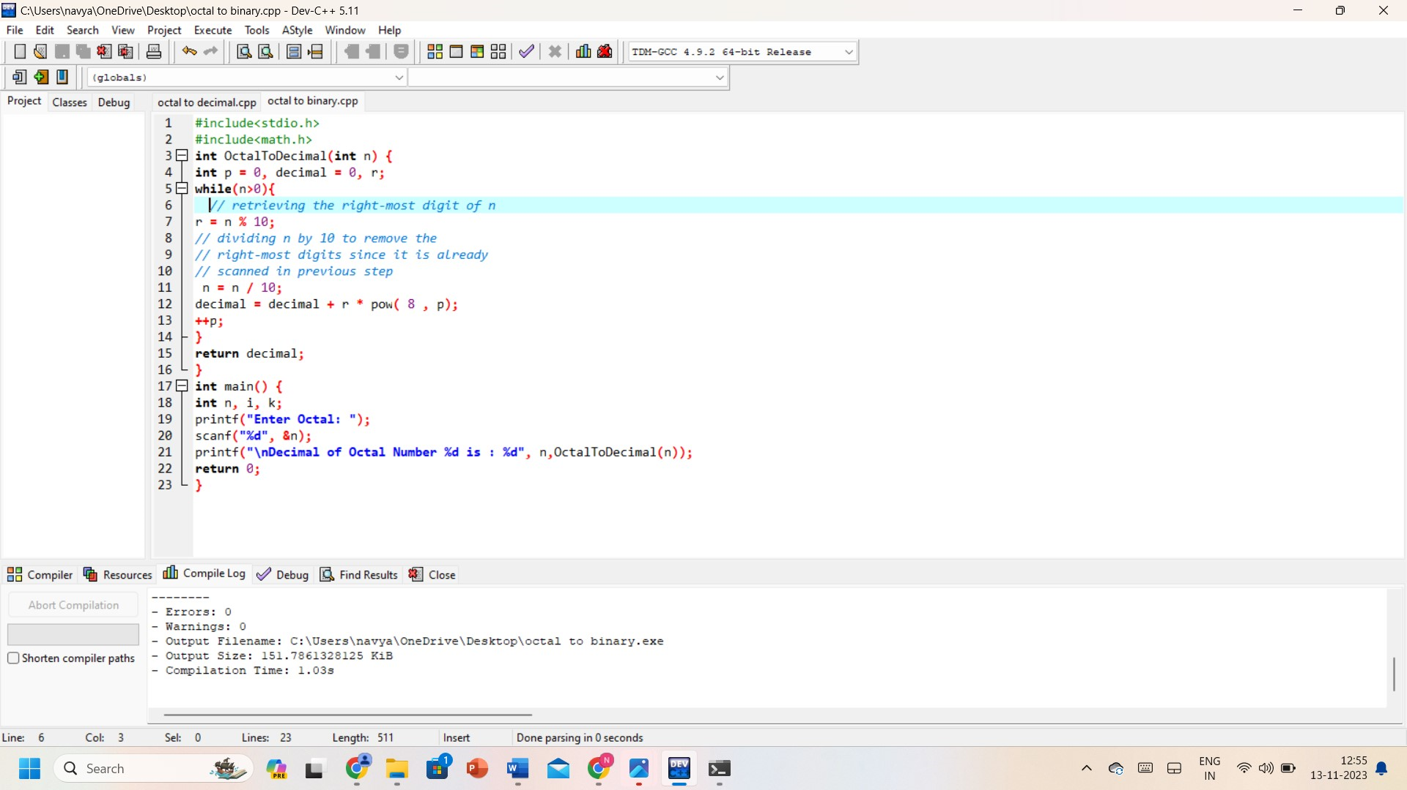

**OUTPUT:**

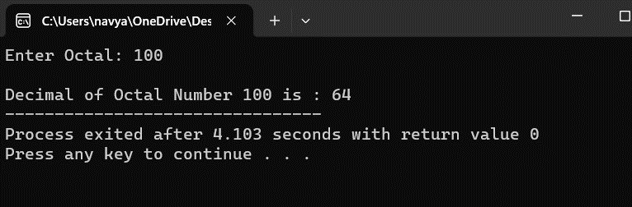

**RESULT:** Thus, the program was executed successfully using DevC++.